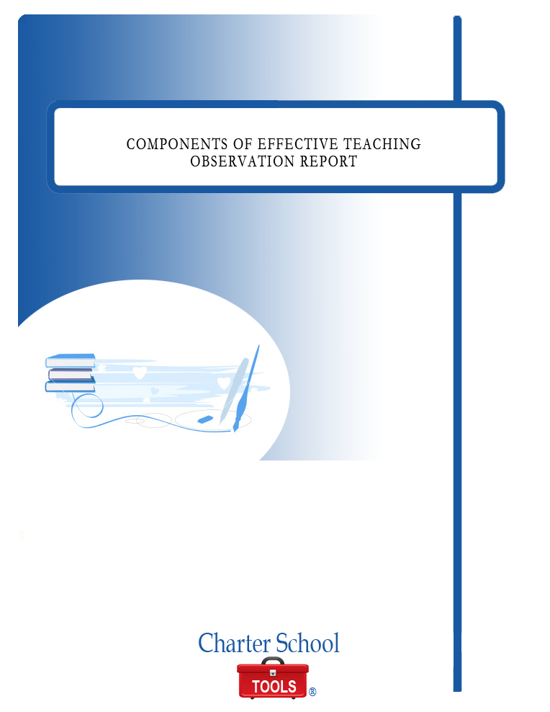

COMPONENTS OF EFFECTIVE TEACHING OBSERVATION REPORT

October 2010



P.O. Box 2228
Baton Rouge, LA 70821
225.387.8605
www.charterschooltools.org
info@charterschooltools.org

Teacher: |  | School:
Date: | Grade Level: | Subject:

Class Size______________ Highlight 0-3 or 4+ Yrs Length of Observation___________________________
Pre-Observation Conference Post Observation Conference

Criteria: E – Exceeds M – Meets P- Progressing DM – Does Not Meet NA – Not Applicable
Planning – Demonstrates competence in planning and preparing for instruction

Criteria: E M P DM NA

a. Utilizes state standards, and the school curriculum in planning for projects
b. Driving questions focus on enduring understanding
c. Uses students’ data to plan differentiated activities
d. Includes explicitly taught and assessed by project work or that will be encouraged by 21st Century skills
e. Method of assessment identified
f. Identify resources including technology as needed for projects in the development and sequencing of the project
g. Identify activities that lead students to answering the driving questions

Comments:
Top of Form
<TEXTAREA ROWS=\
Bottom of Form

II - Classroom Climate – Provides an atmosphere conducive to learning consistent with school mission.

Criteria: E M P DM NA

a. Promotes a safe and positive learning environment
b. Creates a learning community that encourages positive social interaction and self-reflection by students
c. Manages classroom transitions and projects in a timely and orderly fashion
d. Establishes procedures and rules that support high expectations for student behavior
e. Promotes high expectations for student/group performance and/or presentation of quality work
f. Treats students in a fair and equitable manner

Comments:
Top of Form
<TEXTAREA ROWS=\

III – Instructional Management– Organizes teaching strategies to maximize the use of allocated instructional time to increase student learning.

Criteria: E M P DM NA

a. An agenda posted with instructional activities identified
b. Reviews previous materials and/or activities as appropriate
c. Students working collaboratively in groups
d. Students assigned authentic work that is developmentally appropriate
e. Incorporates higher level thinking skills and encourages students to express ideas clearly and accurately
f. Directs and adequately supervises students to be on task quickly at the beginning of each instructional activity
g. Maximizes student time-on task in groups and/or independently
h. Forms effective transition between instructional activities
i. Engages students in activities that involve real-life connection, and prior knowledge and experience
j. Demonstrates flexibility in adjusting instruction when appropriate
k. Integrates a variety of technology applications and learning tools to enhance student achievement
l. Demonstrates ability to communicate effectively with students

Comment:
Top of Form
<TEXTAREA ROWS=\
Bottom of Form
Top of Form
Bottom of Form

IV - Instructional Content Knowledge – Demonstrates competence in content knowledge appropriate to subject(s) taught

Criteria: E M P DM NA

a. Presents accurate content at a developmentally appropriate level
b. Content is rigorous and relevant
c. Content is consistent with the LCC
d. Relates relevant real-life examples and/or current events to the content
e. Answers questions correctly and/or direct students to additional resources
f. Integrates subject content appropriately for projects
g. Understands and uses various instructional strategies that are appropriate to the content areas

Comment:
Top of Form
<TEXTAREA ROWS=\

V – Student Progress – Demonstrates the ability to monitor, assess and facilitates student academic achievement

Criteria: E M P DM NA

a. Consistently monitors and evaluates student performance
b. Uses appropriate and effective assessment techniques (i.e. rubrics, formative and summative assessments, etc)
c. Provides timely feedback to students regarding their progress
d. Maintains accurate and complete student records
e. Follows grading policies and regulations
f. Monitors student attendance

Comment:
Top of Form
<TEXTAREA ROWS=\

VI – Professional Work Habits – Demonstrates behavior which reflects professional responsibilities

Criteria: E M P DM NA

a. Adheres to established laws, policies, school procedures, rules and regulations
b. Demonstrates professional and ethical conduct as defined by state law and school policy
c. Interacts appropriately with students, parents and other personnel
d. Punctual with reports, grades, records and in reporting to work
e. Leads by example in appearance, manners, behavior and language
f. Teacher’s Professional Growth Plan is in place
g. Participates in activities that foster professional growth
h. Performs additional duties as requested

Comment:
Top of Form
<TEXTAREA ROWS=\

VII – Community Involvement – Establishes relationships with stakeholders (parents, community and colleagues)

Criteria: E M P DM NA

a. Provides clear and timely information to parents/guardians and colleagues regarding classroom expectations, student progress and ways they can assist learning
b. Encourages parents/guardians to become active partners in their children’s education and to become involved in school and classroom
c. Seeks community involvement in instructional programs (i.e. guest speakers, field trips, etc)
d. Utilizes the downtown community as a learning tool to engage students

Comment:
Top of Form
<TEXTAREA ROWS=\

VIII – Technology Competency – Demonstrates knowledge in the implementation of technology to improve student achievement

Criteria: E M P DM NA

a. Demonstrates a sound understanding of technology operations and concepts
b. Plans and designs effective learning environments and experiences supported by technology
c. Implements curriculum plans that include methods and strategies for applying technology to maximize student learning
d. Utilizes the downtown community as a learning tool to engage students
e. Applies technology to facilitate a variety of effective assessment and evaluation strategies
f. Understands the social, ethical, legal and human issues surrounding the use of technology in schools and applies that understanding in practice

Comment:
Top of Form
<TEXTAREA ROWS=\

