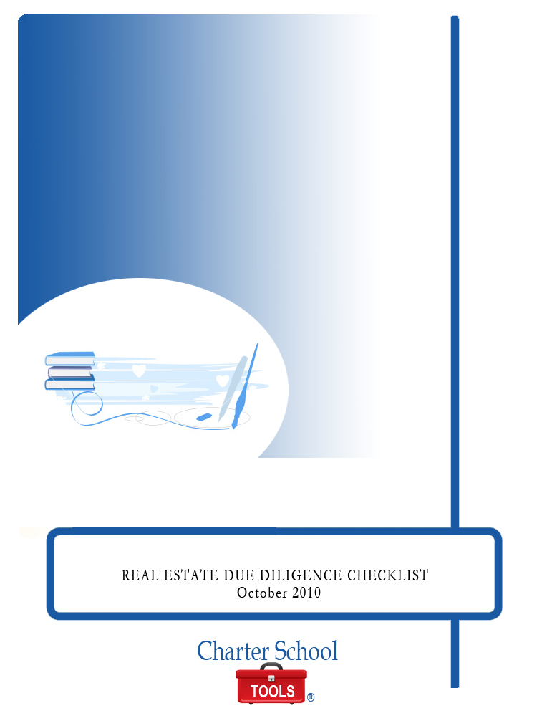

REAL ESTATE DUE DILIGENCE CHECKLIST

October 2010



P.O. Box 2228
Baton Rouge, LA 70821
225.387.8605
www.charterschooltools.org
info@charterschooltools.org

Copyright © 2010, Charter School Tools. All rights reserved.

Due Diligence Checklist
Property =
Buyer / Developer =
Buyer’s Counsel =
Seller =
Seller’s Counsel =
Title Company =
Equity Partner =
Leader =
Master Plan Architect =
Property Manager =
Environmental =
Geotechnical =
Structural =
Traffic =
Broker =

 | Responsible Party | Status | Due Date | Tab

PROPERTY DETAILS

Location

Address

Building Type

Type of Construction

Building Size

Topography

Special Conditions/Cost

Access/Traffic

Environmental Access

Parking

Exclusions to net acreage

Summary of site history, ownership & development
(any development agreements)

General inspection of the improvements, including the following:

Interior and exterior maintenance;

Occupied and vacant spaces;

Restrooms and public facilities;

Restrooms and public facilities and;

Property Condition Report

Obtain cost estimates for deferred maintenance / Determine rehab budget

Copies of any ground leases, master leases, joint venture agreements

Copies of site plans, leasing brochures, maps and photographs

List of all personal property

Existing property inspection reports, including:

structural systems;

mechanical and electrical equipment;

fire and life safety systems;

roof;

curtain wall;

parking lot;

utility service;

deferred maintenance;

underground garage;

elevators;
- ADA compliance;

Obtain and review warranties on:

Roof;

HVAC equipment;

Fire water pump equipment

General contractor warranty;

Major subcontractor warranties:

Electrical;

Elevators;

Concrete;

Windows;

Flooring/carpet;

Landscaping;
  - Parking lot surfaces

List of all hazardous materials known to be in use at property.

Existing environmental study

As-built plans and specs (including mechanical, electrical and structural)

Certificate of occupancy & building permits, licenses, approvals and/or exemptions

Copies of all insurance policies covering property

Contact insurance to arrange for coverage

Sales comparable and/or rent comparable study

Current market reports and vacancy data

PROPERTY OPERATIONS

Current rent roll

Standard form of lease

Monthly operating statements for last 2 years

Utility bills for last 3 years (electric, water & gas)

Obtain and review real property tax bills for last 3 years and most recent tax bill (any increases, special assessments forthcoming)

Monthly delinquency report for past 3 years and budgeted for next 2 years

Schedule of capital improvements over past 3 years and budgeted for next 2 years

Operating and service agreement contracts and lease agreements - Prepare summary of contracts including:

Vendor name;

Services provided;

Term;
      - Charges

Property management agreement

TENANT INFORMATION

Tenant Status

All tenant lease agreements and amendments

Current financial statements for all tenants and lease guarantors

Profile and background on each tenant

Tenant estoppel certificates

Copies of all tenant correspondence for the past 3 years

Summary of pending leases and terms

CONTRACT/LEGAL

Negotiate purchase & sale (price, deposit)

Timing (deposit, due diligence, close of escrow)

TITLE/SURVEY

APNs

Escrow (title office, escrow number)

Preliminary Title Report

Liens

Assessments

Easements

Access

Environmental

CC&Rs

Zoning

Other

Copies of all underlying title and exception documents

UCC and judgment lien searches in Seller

ALTA as-built survey

Copies of subdivision and parcel maps

Restrictive covenants, easements and common area agreements

Description, ownership and operation of adjacent land uses

Flood zone certificate and seismic zone map

Obtain PML study

Title policy – estimate of cost of title policy

ENVIRONMENTAL

Obtain and review Phase I Environmental Site Assessment

Soil sampling

Groundwater sampling

Underground storage tanks

Asbestos report

Lead paint and radon testing

VEGETATION/BIOTA/WATER/OTHER

Usefulness of vegetation

Evaluate endangered species concerns

Natural water on site (usefulness/flood hazard)

Erosion potential

Subsidence potential

Fault zone potential

Noise/vibration

Toxics/chemicals

High winds

Incompatibly zoned neighbors

LITIGATION

Review current and threatened actions against Seller with respect to the Property

Review any governmental actions or suits concerning the Property

ZONING & ENTITLEMENT STATUS

Obtain copy of zoning ordinance applicable to the Property

Confirm zoning classification, obtain zoning compliance letter and examine development standards:

Density;

Site coverage, footprint

Public use (open space, roadways, parks, schools);

Height, setback requirements;

Design criteria;

Landscaping requirements;

Signage restrictions

Sprinkler/Fire life safety requirements;

ADA requirements;

Parking requirements & restrictions;

Traffic mitigation;

Exactions;

Subdivision compliance;

Affordable housing restrictions, if any;

Historic/landmark district restrictions, if any

Investigate any planned zoning changes

Obtain and review copy of any conditional use permit:

SIC Codes permitted

Examine use permit restrictions

Determine transferability of entitlements

Obtain and review all other permits, authorizations, licenses and certificates, including:

Elevator permits and most recent certification;

Fire alarm and life safety system certifications;

Business licenses and applications, if any

LOCAL ADVICE

Advice of:
- Sellers/owners
- Local civil/soils engineers
- Planning
- Public Works
- Architects
- Neighbors
- Community outreach groups

GOVERNMENTAL

Political situation of the City

City Council

Redevelopment Agency

Planning Commission

Politics of the site

Neighborhood politics

City/State/Redevelopment Agency Entitlement Process (CEQA, SEQR, City entitlements, Agency entitlements, Approvals)

City Fees

UTILITIES
  - Water
  - Sewer
  - Electricity
  - Gas
  - Telephone

MISCELLANEOUS

[To be determined]

