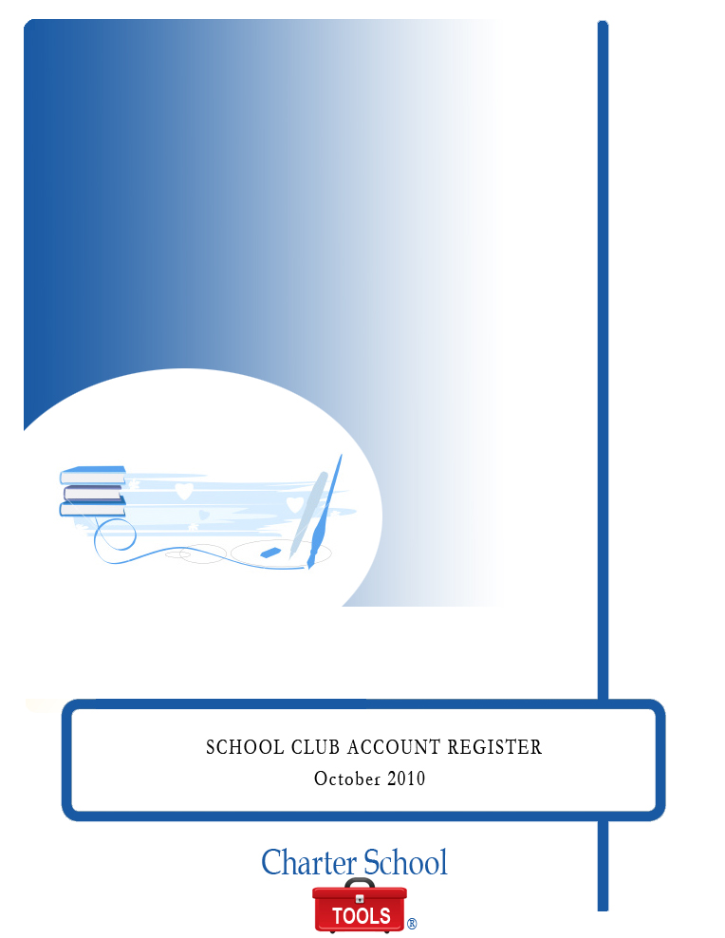

SCHOOL CLUB ACCOUNT REGISTER

October 2010

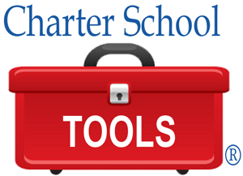

P.O. Box 2228
Baton Rouge, LA 70821
225.387.8605
www.charterschooltools.org
info@charterschooltools.org

Copyright © 2010, Charter School Tools. All rights reserved.

School Club Account Register Instructions

- Enter the school name
- Enter the club/activity name
- Enter the receipt number if a receipt was given for the collection
- Enter either the check number or "cash" depending on the transaction
- Enter the date you received the collection or the date that the payment was made
- Enter the date the funds were deposited if it was deposit transaction
- Enter a description of the transaction
- Enter the vendor/payee name who you received the funds from or made the payment to
- If the transaction was the receipt of funds, enter that amount in "Debit (+)" column
- If the transaction was a payment/withdrawal from club funds, enter that amount in "Credit (-)" column
- The final balance will be the balance of the club, fundraiser, etc., has available to spend. The balance of your School Club Account
  - Register should balance to the Fundraiser Financial Report the sponsor submits to you and to the accounting ledger.
  - If there are any discrepancies of the balances a review should be done to reconcile the differences and adjust the records and reports accurately.
- The SOM should submit all School Club Account Registers to Finance by the 5th of the following month, or the first SOM meeting of that month.
  - If there are any discrepancies between the two records, Finance will locate the variances and adjust either finance records or contact the SOM if there records are incorrect to adjust. It is up to the SOM to reconcile any differences between their records and the Fundraiser Financial Report if there are any.
- At the end of the school year, SOMs should submit the signed Fundraiser Financial Report and all back up to Finance after are reconciliations have been completed and discrepancies have been adjusted.
NOTE: ALL DEPOSITS MUST BE MADE AT A MINIMUM WEEKLY IF THEY ARE UNDER $500 AND WITHIN 48 HOURS IF THEY ARE OVER $500.

FOR NO REASON SHOULD ANY FUNDS COLLECTED BE USED AS PETTY CASH OR TO PAY PEOPLE FOR SERVICES SUCH AS SECURITY WORKERS, REFEREES FOR GAMES, CONCESSION WORKERS, ETC

School Club Account Register Form
School:

Club:

Receipt No. | Check No./Cash | Date  Collected | Date  Deposited | Description of Transaction | Vendor/Payee | C | Debit  (+) | Credit  (-) | Balance

School Club Account Register Sample Form

School:

Club:

Receipt No. | Check No./Cash | Date  Collected | Date  Deposited | Description of Transaction | Vendor/Payee | C | Debit  (+) | Credit  (-) | Balance
520205 |  | 9/4/09 | 9/7/09 | Collection of club dues | Student Collections |  | $78.00
520301 |  | 9/22/09 | 9/22/09 | Collection of club dues & donations | Student Collections |  | $120.00
 |  | 9/23/09 |  | Payment of club dues to 4H Foundation | 4H Foundation |  |  | $105.00
520208 |  | 10/9/09 | 10/11/09 | Donations collected for Disney trip |  |  | $318.30
 |  | 10/14/09 |  | Items purchased for concession | Sam’s |  |  | $56.71
520209 |  | 10/21/09 | 10/22/09 | Gross proceeds from concession sales | Concession Sales |  | $122.02
 | 3805 | 10/30/09 |  | Bus deposit to Calco Transportation | Calco Transportation |  |  | $100.00
520218 |  | 10/30/09 | 10/30/09 | Gross proceeds from Soc Hop admission and concession | Parents & Students |  | $937.92

