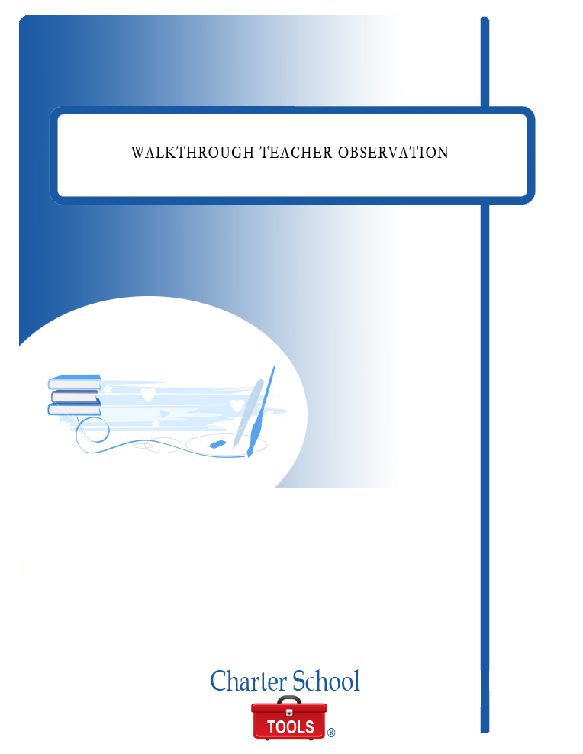

WALK THROUGH TEACHER OBSERVATION

October 2010



P.O. Box 2228
Baton Rouge, LA 70821
225.387.8605
www.charterschooltools.org
info@charterschooltools.org

Copyright © 2010, Charter School Tools. All rights reserved.

Teacher: Time:
Course: Date:
CLASSROOM ENGAGEMENT
□ Student Centered/Dominated □ Student/Teacher Dominated □ Teacher Directed/Dominated
□ Cooperative Grouping □ Lecture/Whole Group Instruction □ Independent/Hands-On Activity

Comments/Supporting Evidence:
Top of Form
<TEXTAREA ROWS=\
Bottom of Form
RATINGS
E = Excellent S = Satisfactory NI = Needs Improvement N/A = Not Applicable
 | E | S | NI | N/A
Agenda displayed and/or daily goal posted
Directions given and repeated as needed
Effective classroom management/discipline
Teacher monitoring/assessing
Environment conducive to learning
Effective use of instructional strategies
Maximum use of instructional time
Positive motivation/praise used
Use of Real-Life connections/experiences
Use of Technology
Students know the essential/driving question
Students actively engaged
Meaningful and purposeful student discussions
Respectful/supportive interactions between students and between students and teachers
Use of Differentiated Instruction
Bloom’s Taxonomy Level (circle)
Evaluation Synthesis Analysis Application Comprehension Knowledge

Comments/Supporting Evidence:
Top of Form
<TEXTAREA ROWS=\
Bottom of Form

Observer Signature Date

Observee Signature Date

